**RIPHAH INTERNATIONAL UNIVERSITY ISLAMABAD**



LAB#3

Bachelors of Computer Science – 5th Semester

Subject: Operating System

Submitted to: Miss Kousar

Submitted by: Maryum Malik

Sap ID: 45369

**Q1.** Make the following directory (03 Marks)

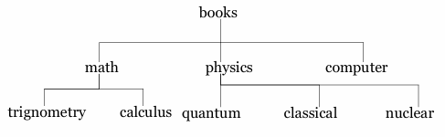

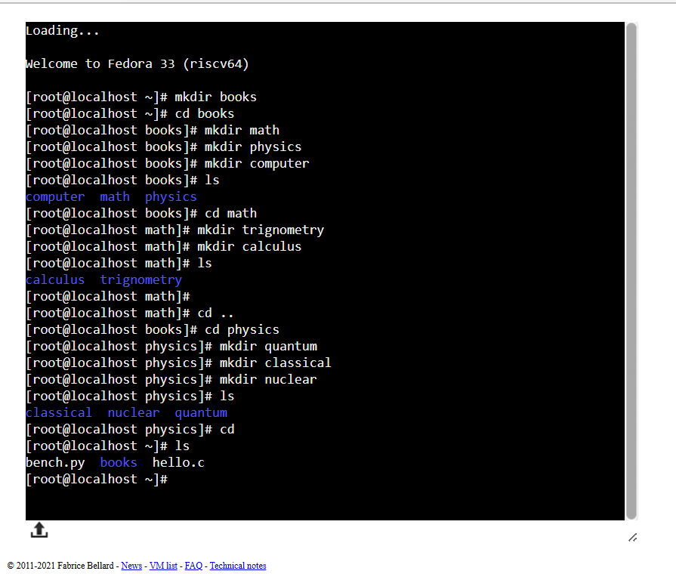

**Q2.** Which are the Linux Directory Commands? Explain the understanding of commands in your own words. Also define what is BASH?

**ls:** This command lists the contents of a directory.

**cd:** Stands for "change directory." It allows you to navigate between directories.

**pwd**: Stands for "print working directory." It shows the current directory you are in. This helps you understand where you are in the file system.

**mkdir**: Stands for "make directory." It is used to create a new directory.

**rmdir**: Stands for "remove directory." It deletes an empty directory.

**rm:** Stands for "remove." It is used to delete files or directories.

**cp**: Stands for "copy." It copies files or directories from one location to another.

**BASH:**  stands for **Bourne Again Shell**. It is a command-line interpreter that provides a command-line interface for interacting with the operating system. Developed as a free software replacement for the Bourne Shell (sh), BASH is widely used in Linux and other Unix-like operating systems.

**Q3.** 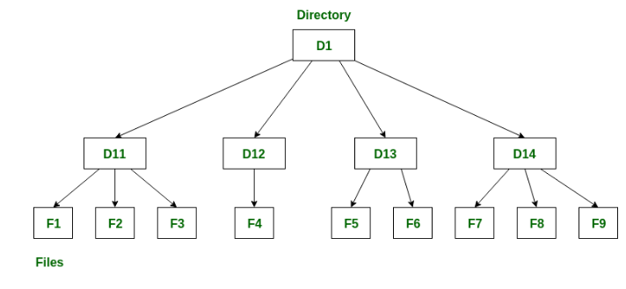

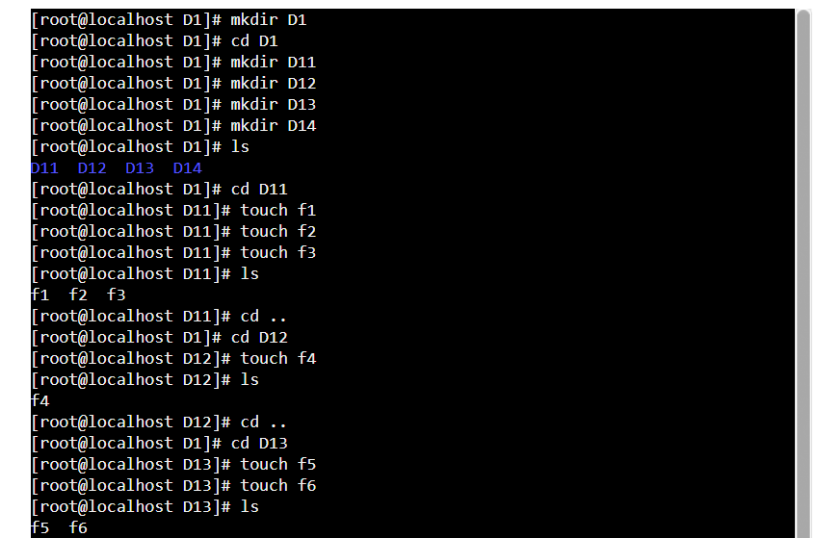

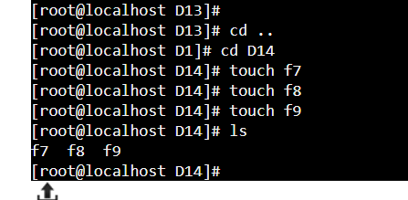

**Q4.** Make the following directory (03 Marks)

